## The Shapes Properties

A shape is defined by its outline and an internal area - each handled separately. Similar to lines, the **shape’s** outline style is set by altering the stroke settings. The properties for the internal area are set by modifying the fill used for the shape.

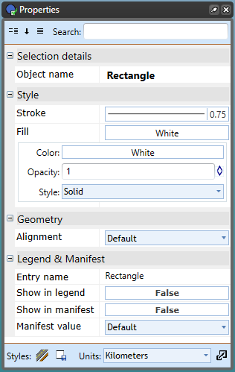

Rectangle_Properties_Palette

You have three controls for the fill: **Color, Opacity and Style.**

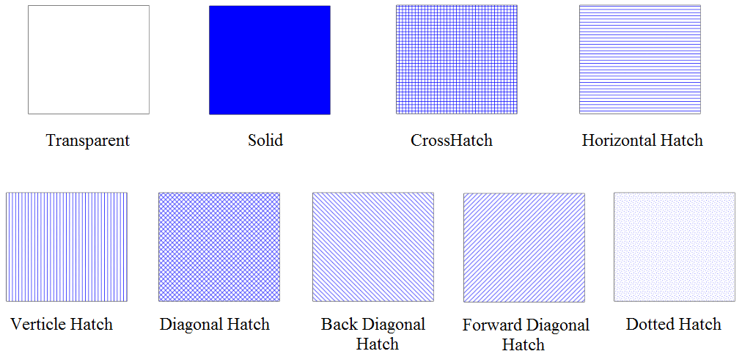

The_Available_Shape_Fill_Styles

## The “Transparent” Color

One of the color settings for lines, shapes and text is **transparent**. In the case of lines including shape outlines this effectively just means **none**. For the fill of shapes however, a transparent setting allows you to see what’s underneath. Don’t confuse **transparent** with **white**. As the diagram below shows, they are very different.

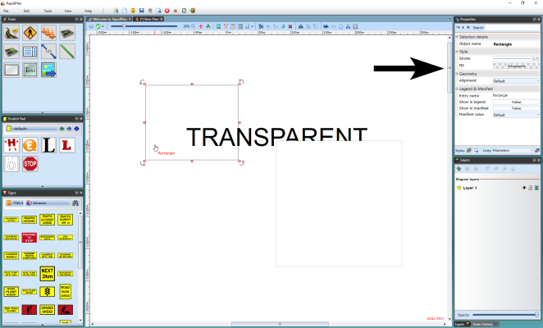

The_Box_on_the_Left_has_a_Transparent_Fill